`

THE GREAT LAKE RACE 2026

SAILING INSTRUCTIONS
- RULES
  - Races will be governed by the rules as defined in the Racing Rules of Sailing, 2025-2028 edition herein after referred to as the “rules”.
  - The U.S. Sailing Prescriptions and addendum, will apply.
  - If a conflict exists between any of the above and the CSA Sailing Instructions, the CSA instructions will prevail.
  - RRS 26 is altered, modifying the start for a pursuit race. RRS 52 “Manual Power” is modified to allow the use of winches operated by using stored power but not for the use of auto-helms at any time while racing.

- NOTICES TO COMPETITORS
  - Notices will be posted on line at NextSailor.com and the regatta notice board at the “Skipper’s Party” Friday night at New Orleans Yacht Club (NOYC).
  - Any changes to these instructions after the Skipper’s Meeting will be posted on the official notice board on-line at NextSailor.com.

- DIVISIONS
  - Spinnaker Division
  - Spinnaker Class boats may carry a spinnaker as defined by the rules & the ORR EZ rating.
  - Non-Spinnaker Division
  - Headsails. A single headsail, of the maximum size specified by the ORR EZ rating, or smaller, may be carried and tacked at the usual tack point. During headsail changes, if two headsails are carried, their clews must both lie on the same side of the boat.
  - Whisker Poles—Whisker Pole length is unrestricted. Whisker Poles must be attached to the mast and at or adjacent to the clew of the headsail. Only one whisker pole may be carried at a time.
  - Spinnakers, Bloopers or Pole less Spinnakers are not allowed.
  - Staysails are allowed, if tacked on centerline, a minimum of 1/3 of the “J” dimension behind the jib tack point and shall not exceed the rated overlap distance for which the boat is rated.
  - Cutter Rigs boats rated as such by PHRF may set staysails to the tack point provided by the boat manufacturer.
  - Yawl and Ketch Rigs-- Mizzen staysails may be carried.

- RACE SCHEDULE
  - The race will be sailed on Saturday September 19, 2026. In the event that the race is abandoned for any reason, the race will be rescheduled at a date to be determined. It will be the individual Skipper’s responsibility to keep their crew informed of all schedule changes.
  - The race start sequence will be a “Staggered Start” based on EZ BM# ratings.

- CLASS FLAGS
  - There will be no class flags.

- RACING AREA
  - The racing area is on the Southshore of Lake Pontchartrain between the Causeway Bridge and the Lakefront Airport. Attachment “A” is a chart showing the locations of the racing area and fixed marks.

- THE COURSE
  - The course will be either a twenty mile OR a twelve-mile Steeple Chase around fixed marks located on the South Shore of Lake Pontchartrain. The order and the rounding of the Marks are listed in Attachment B. All or some classes may sail a shorter course at the discretion of the Race Committee.
  - A 20 NM or 12 NM Course shall be selected at the skipper’s meeting.

- MARKS
  - Marks shall be fixed yellow marks.
  - Replacement marks may be temporary orange tetrahedrons or orange or yellow buoys.

- THE START
  - The starting line will be between an orange flag on the race committee boat and the nearby “A” Mark.
  - A list of Start Times will be made available at the Skipper’s Meeting and posted on NextSailor.com. The RC boat will hoist the “I” flag and make a sound at 8:56. Boats called over early must return around the ends of the start line in order to restart. The “I” flag will remain up until all boats have started. This alters RRS 26. The boat with the highest rating will have a start time of 9:00.
  - A boat is racing four minutes before their start and may run their engines until they are “Racing”. Boats not racing, shall avoid the starting area. Violators of this rule are subject to protest and may be disqualified.
  - At the START, each crew member must be on deck and wearing a life jacket. Violators will not be scored.
  - Skippers are responsible for starting at their Boat’s assigned Start Time, using GPS time. The Race Committee will also sound a horn at each boat’s designated Start Time.
  - Individual Recall: When at a boat’s starting signal, if any part of her hull is on the course side of the starting line, or she must comply with rule 30.1. The race committee shall promptly display the X flag with one sound. The flag shall be displayed until the hull of the boat is completely on the pre-start side of the starting line or one of its extensions. As the “I” flag is up, boats must return to the starting area around the ends of the Starting line.

- POSTPONEMENT
  - The AP Flag will be raised with 2 short horn blasts and remain flying during the postponement period.
  - No boats shall start if the AP Flag is flying.
  - Postponements will be made in increments of 10 minutes.
  - Once the AP flag comes down the L flag will be used to notify that a postponement has occurred.
  - A numerical pennant flag will also be flown to indicate the number of 10-minute increments.
  - The Race Committee will also broadcast on Channel 69 that a postponement has occurred and its duration.
  - Skippers will need to adjust their start time accordingly by adding the postponement period to their published start time.

- THE FINISH
  - The Finish Line shall be between the orange flag displayed on the committee boat and the finish mark.
  - The course may be shortened at any mark. The Race Committee will raise the “S” flag and make two sounds on the horn. Additionally, the RC will make an announcement on VHF channel 69.
  - The Race Committee will record the finish times and which may be adjusted for a shortened course.

- TIME LIMITS
  - Boats that have not finished by 1600 will be scored TLE.

- PROTESTS AND REQUESTS FOR REDRESS
  - A boat intending to file a protest shall inform the Race Committee of the protested boat’s sail number and name upon finishing or at the first reasonable opportunity.
  - Hearing request forms are available in the NOYC office.
  - Hearing Request Forms shall be deposited in the box located at the NOYC office within two (2) hours of the protesting boat’s recorded finish time. Protesting boats shall indicate on the protest form the time the form is deposited in the Protest box.
  - The Protest Committee will hear protests in the approximate order of submission. The Protest hearing schedule will be posted on Notice Board at the NOYC Office.
  - Skippers of boats involved in the protest must be available for the protest hearing.

- SCORING
14.1 Each yacht will be scored in the order of its finish by class and fleet. The staggered start system adjusts for
corrected time by applying a handicap to starting time vs. distance. In the event of a shortened course, corrected times will be calculated based on the new distance and finishes will be ordered by the corrected times.

- SAFETY REGULATIONS
  - It is the sole responsibility of each skipper to determine if his boat and crew are capable of participating in the race. Each skipper is reminded to comply with all applicable State and Federal safety regulations.
  - Radio. The race committee shall operate on and monitor VHF channel 69. Competitors shall monitor VHF Channel 69 during the race.

- MISCELLANEOUS
  - Trash and Debris. No trash or debris will be thrown overboard at any time. Violators are subject to protest and disqualification.
  - Trophies will be awarded as announced.
  - Yachts retiring or withdrawing from the race MUST inform the Race Committee Boat via VHF radio channel 69.

ATTACHEMENT “A”

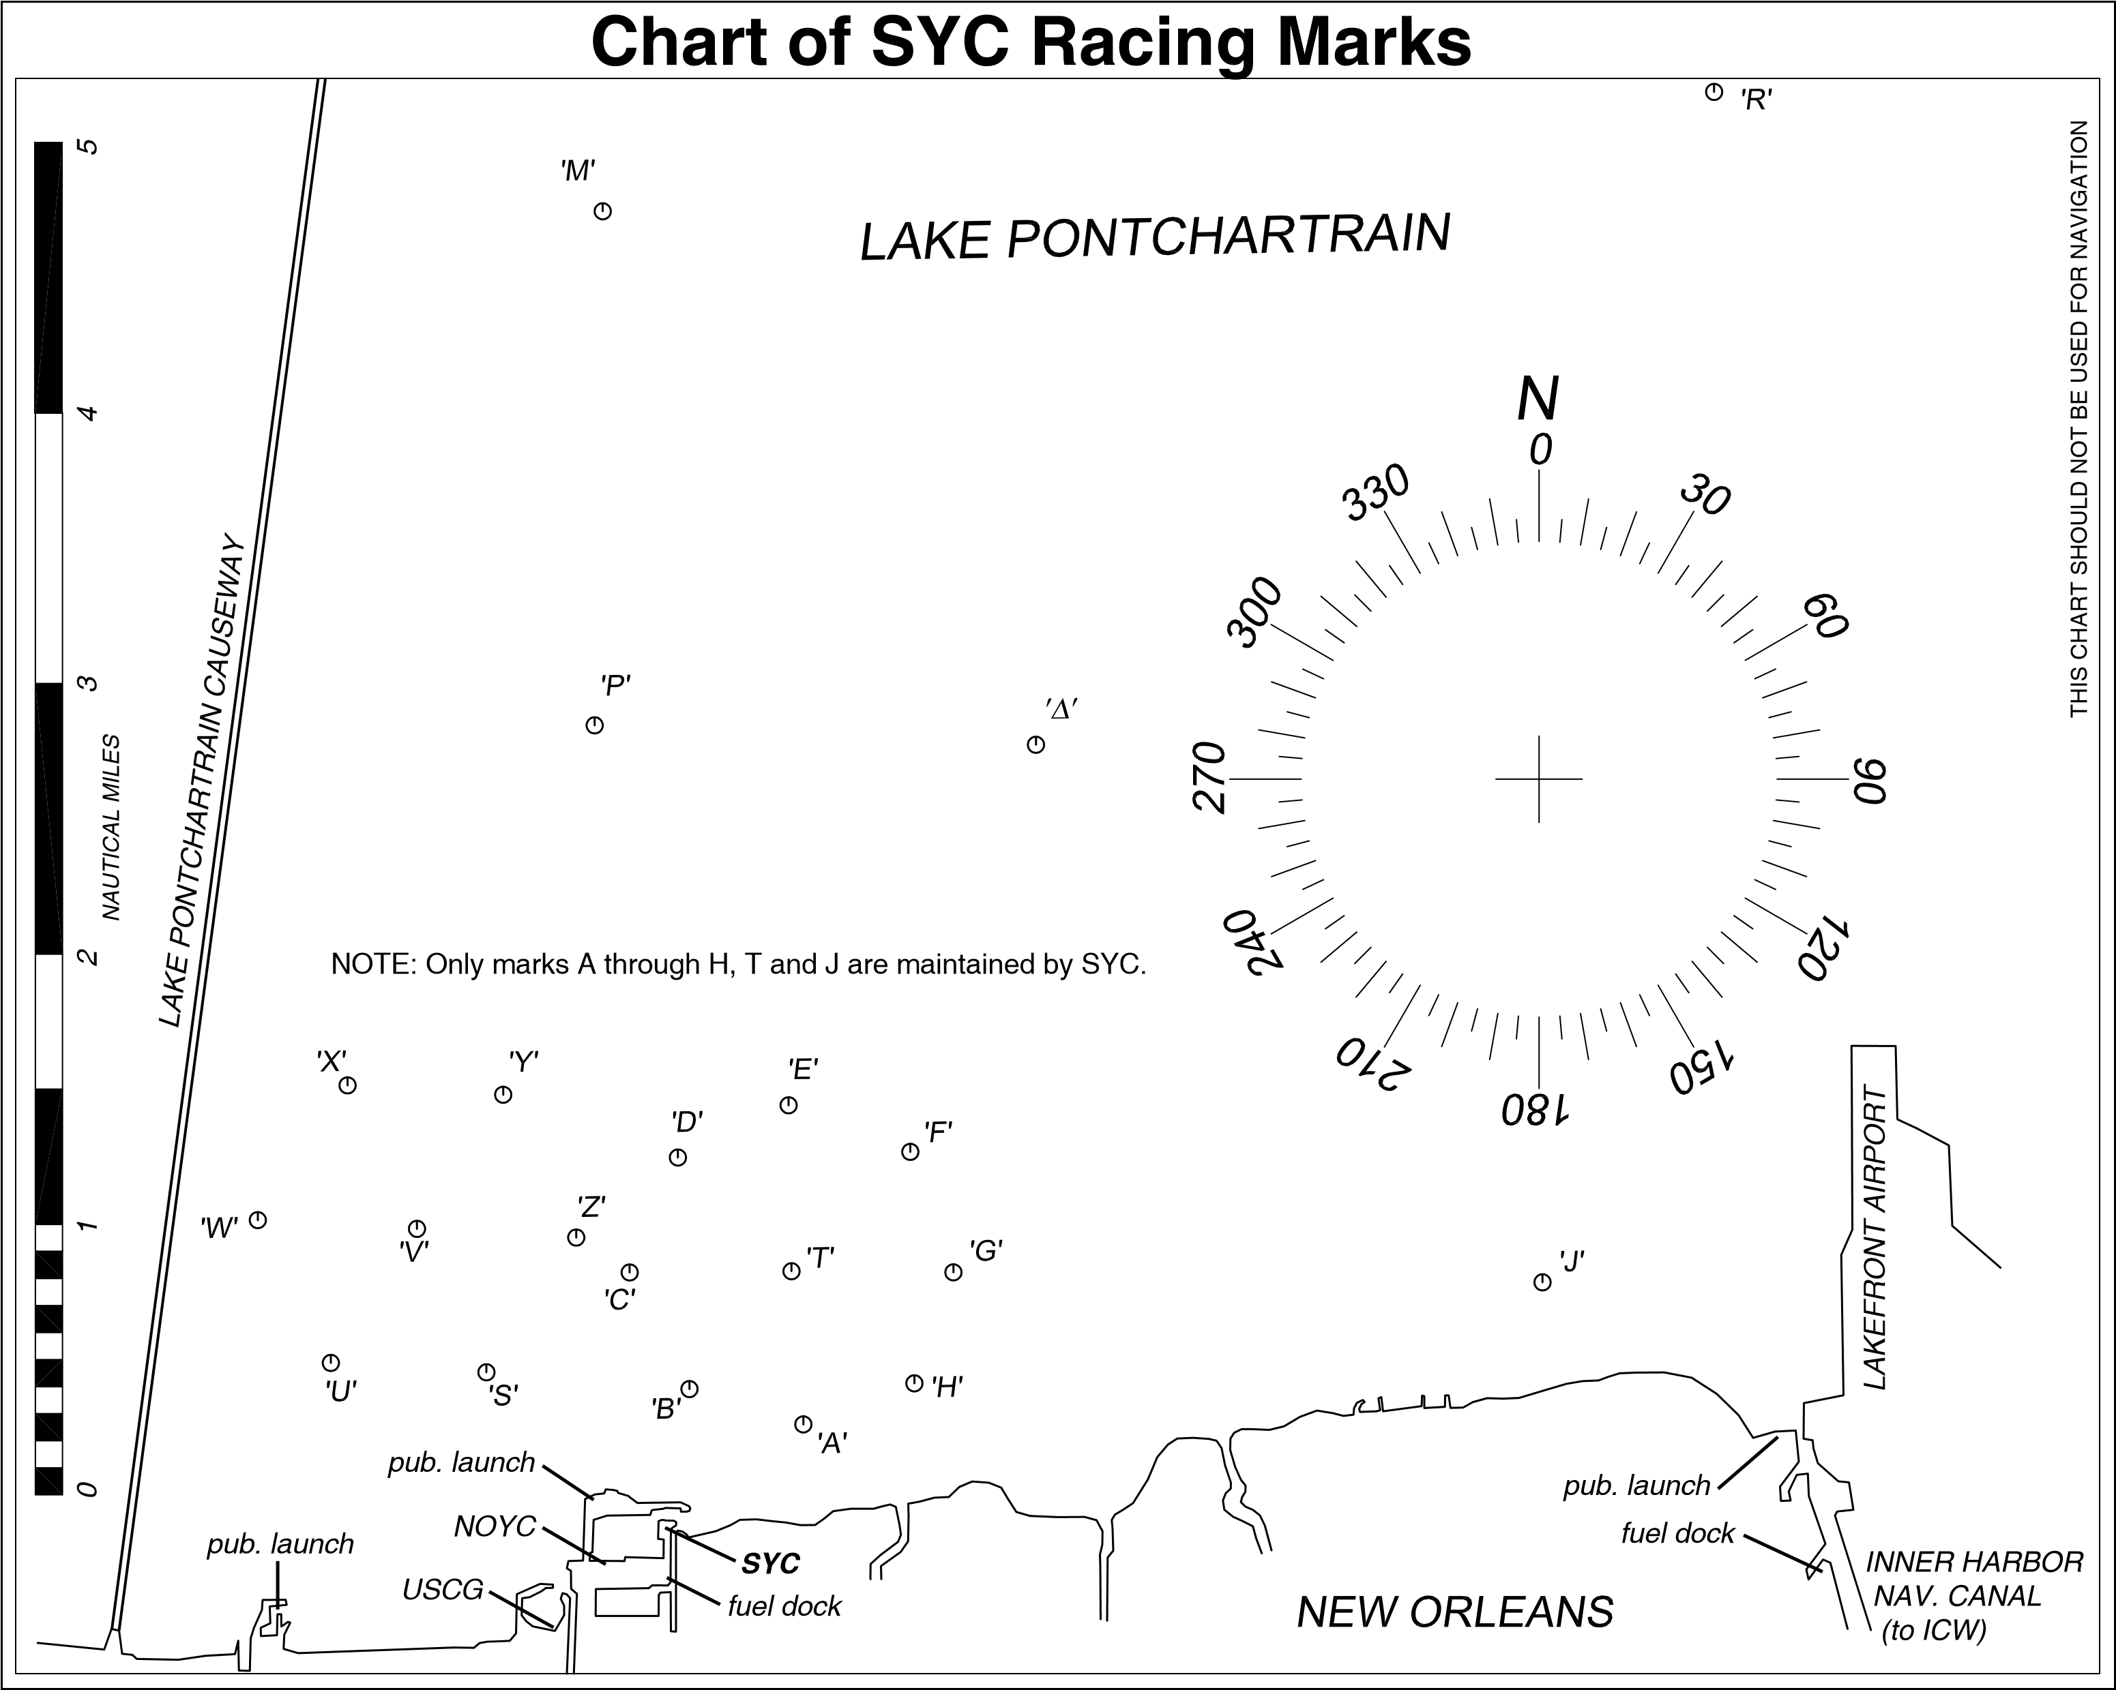

Attachment “B”

Courses 1 (20 NM) Course 2 (12NM)
Mark | Rounding | Bearing (deg) | Dist (NM) | Dist Sailed |  | Mark | Rounding | Bearing (deg) | Dist (NM) | Dist Sailed
A to J | Port | 079 | 2.73 |  |  | A to J | Port | 079 | 2.73
J to E | Port | 285 | 2.77 | 5.50 |  | J to E | Port | 285 | 2.77 | 5.50
E to W | Port | 261 | 2.08 | 7.58 |  | E to S | Port | 234 | 1.47 | 6.97
W to Z | Port | 091 | 1.15 | 8.73 |  | S to F | Star | 67 | 1.76 | 8.73
Z to F | Star | 082 | 1.33 | 10.06 |  | F to H | Star | 180 | 0.85 | 9.58
F to J | Port | 103 | 2.32 | 12.38 |  | H to Z | Port | 296 | 1.47 | 11.05
J to DELTA | Port | 318 | 2.70 | 15.08 |  | Z to A | Star | 133 | 1.22 | 12.27
Delta to H | Star | 191 | 2.37 | 17.45 |  | Actual Distance |  |  | 12.27
H to Z | Port | 296 | 1.47 | 18.92
Z to A | Star | 133 | 1.22 | 20.14
Actual Distance |  |  | 20.14

