CANDLER
SAILING INSTRUCTIONS
Viper 640

1 RULES
1.1 The regatta will be governed by the rules as defined in The Racing Rules of Sailing. All reference to “Rule” refers to The Racing Rules of Sailing. All references to “Instruction” refers to these sailing instructions.

2 NOTICES TO COMPETITORS
Notices to competitors will be posted on the official notice board located on the windows upstairs at the sailing center. At the end of the day of racing the race committee will post its docking time as well as any boats that it plans to score in other than their finishing position (flag “L” will NOT be displayed with this notice.) Notices of hearings will be posted here within 20 minutes of the expiration of protest time in accordance with sailing instruction 16 c (flag “L” will NOT be displayed with this notice.)

3 CHANGES TO SAILING INSTRUCTIONS
Any changes in the sailing instructions will be posted on the official notice board within twenty minutes following the end of the competitors meeting.

4 SIGNALS MADE ASHORE
4.1 Signals made ashore will be displayed at the Club Flag Pole located on the lawn in front
of the Clubhouse.
4.2 When flag AP is displayed ashore, “one minute” is replaced with “not less than 45
minutes” after Flag AP is lowered.

5 SCHEDULE OF RACES
5.1 Saturday Jun 2nd, 2018: First warning signal is 12:25.
(a) Additional Races to follow ASAP Race #1.
5.2 Sunday June 3rd, 2018: First warning signal is 11:25.
(b) Additional Races to follow ASAP Race #1.
5.3 No races will be attempted after 14:00 on the last day of the regatta.

6 CLASS FLAGS
6.1 Capdevielle Viper 640 Class Flag

7 RACING AREAS
Attachment B shows the location of racing areas.

8 THE COURSES
8.1 The diagrams in Attachment A show the courses, the order in which marks are to be
passed, and the side on which each mark is to be left.
8.2 No later than the warning signal, the race committee signal boat will display the
approximate compass bearing of the first leg.

9 MARKS
9.1 Mark 1 will be a green tetrahedron. Offset mark 1a will be an orange ball.
9.2 Mark 2 will be a orange tetrahedron.
9.3 Mark 3 will be a orange tetrahedron.
9.4 New marks, as provided in instruction 12.1, will be yellow tetrahedron. Offset mark 1a will be an orange ball.
9.5 The starting and finishing marks will be the signal boat and the pin boat.

10 AREAS THAT ARE OBSTRUCTIONS
There are no known obstructions in the race course. Competitors are advised to honor the channel markers when transiting from the smaller bay area near the Yacht Club to the larger open bay areas where the race course will be located. In particular, competitors should be aware of shallow areas towards Red Fish Point at red daymarker #18, and also towards the white/blue condos at green daymarker #19.

11 THE START
11.1 Races will be started by using Rule 26 with the warning signal made five (5) minutes before the starting signal.
11.2 The starting line will be between staffs displaying orange flags on the starting marks.
11.3 Boats whose class warning signal has not been made shall stay clear of the starting area during the starting sequence for other races.
11.4 A boat starting later than four (4) minutes after her starting signal will be scored Did Not Start (DNS) without a hearing. This changes Rules A4 and A5.

12 CHANGE OF THE NEXT LEG OF THE COURSE
12.1 To change the next leg of the course, the race committee will lay a new mark (or move the finishing line) and remove the original mark as soon as practicable. When in a subsequent change a new mark is replaced, it will be replaced by an original mark.
12.2 Except at a gate, boats shall pass between the race committee boat signaling the change of the next leg and the nearby mark, leaving the mark to port and the race committee boat to starboard. This changes Rule 28.1.

13 THE FINISH
13.1 The finishing line will be between staffs displaying orange flags on the finishing marks.
13.2 Finished on Course. Stragglers may be finished on course at the discretion of the Race
Committee Boats so finished will receive a finish position.

14 PENALTIES
14.1 For all classes Rule 44.1 is changed so that the Two-Turns Penalty is replaced by the
One-Turn Penalty.

15 TIME LIMITS AND TARGET TIMES
15.1 Mark 1 time limit for each class is 30 minutes.
15.2 Target time for each race is 45 minutes.
15.3 If no boat has passed Mark 1 within the Mark 1 time limit the race will be abandoned.
Failure to meet the target time will not be grounds for redress. This changes Rule 62.1(a).

16 PROTESTS AND REQUESTS FOR REDRESS
16.1 Rule 61.1(a) is changed to add the following requirements for a valid protest: A boat shall
Inform the finish line race committee of her intent to file a protest and the sail number (or other identification) of the protested boat either at the first reasonable opportunity after finishing, or if the protesting boat does not finish, at the first reasonable opportunity, and she must receive confirmation from the Race Committee. Protest forms are available on the official notice board. Protests and requests for redress or reopening shall be delivered there within the appropriate time limit.
16.2 For each class, the protest time limit is one (1) hour after the race committee signal boat has returned to the Club dock.
16.3 Notices will be posted no later than thirty (20) minutes after the protest time limit to inform competitors of hearings in which they are parties or named as witnesses. Hearings will be held in the protest room, located in the second story room of the Club's Sailing Center Building, beginning at the time posted
16.4 Notices of protests by the Race Committee or Protest Committee will be posted to inform boats under Rule 61.1(b).

17 SCORING
17.1 The Low Point System of Appendix A will apply.
17.2 One (1) race is required to be completed to constitute a series.
(a) When fewer than six races have been completed, a boat's score will the total of
her race scores.
(b) When six or more races have been completed, a boat's score will be the total of her race scores excluding her worst score.

18 SAFETY REGULATIONS
18.1 Check-Out and Check-In:
a) Prior to the first warning signal of the day, all boats are required to check in at the race committee signal boat by sailing past the stern and hailing their sail number.
(b) A boat that retires from a race shall notify the race committee as soon as possible.

19 REPLACEMENT OF CREW OR EQUIPMENT
19.1 Substitution of damaged or lost equipment will not be allowed unless authorized by the Race Committee or Protest Committee. Requests for substitution shall be made to the committee at the first reasonable opportunity.

20 EQUIPMENT AND MEASUREMENT CHECKS
A boat or equipment may be inspected at any time for compliance with the class rules and sailing instructions. On the water, a boat can be instructed by a race committee equipment inspector or measurer to proceed immediately to a designated area for inspection.

ATTACHMENT A

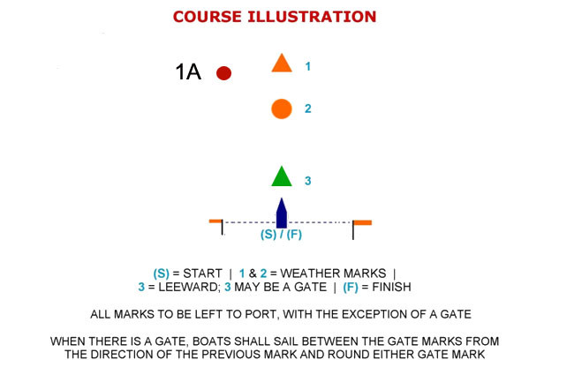

W1=S-1-F
W2=S-1-3-1-F
W3=S-1-3-1-3-1-F
W4=S-1-3-1-3-1-3-1-F
L1=S-2-F
L2=S-2-3-2-F
L3=S-2-3-2-3-2-F
L4=S-2-3-2-3-2-3-2-F

