Welcome to the 2025 annual TYC Single Handed Race event.

- Look at the Rules - remember to call VHF 68 or by phone (985-290-4026) if you drop out. An attempt will be made to hail on channel 68, but due to distances we have asked for cell phone numbers and will use them.

- Have a great race! Official time is GPS Time

Single Handed Race Round The Lake Race
October 4th, 2025

SAILING INSTRUCTIONS

RULES This race will be sailed under the jurisdiction of the Tammany Yacht Club in accordance with the 2025-2028 Racing Rules of Sailing. These Sailing instructions shall govern in the event of a conflict. (RRS Rule 52 modified to allow for the use of an auto pilot)

ELIGIBILITY Eligibility shall be limited to sailing yachts 22 feet LOA or above with self-bailing cockpit. All yachts must provide a valid PHRF certificate or be assigned a handicap by the race committee to include a six second per mile penalty.

CREW Crew is limited to the skipper only. Auto-pilots allowed in all classes.

NOTICES TO COMPETITORS Notices to competitors will be broadcast via VHF (channel 68) as necessary.

CHANGES TO SI Any change to the sailing instructions will be discussed at the skippers’ meeting, sent to the skippers via email, or broadcast via VHF (channel 68) as necessary.

SIGNALS MADE ASHORE There will be none.

SCHEDULE The race is scheduled to start on October 4th as follows.

8:54 am -- “follow me” letter “L” flag comes down
8:55 am --warning signal
8:56 am – preparatory signal
8:59 am – prep flag removed
9:00 am – Start*,
* The Race Committee shall decide if separate starts for each Class are warranted. If so they shall be at 5-minute intervals.

CLASS FLAGS (If Necessary)

Spinnaker Blue flag
Non-Spinnaker Red flag

RACING AREA The racing area will be the Northeast portion of Lake Pontchartrain, starting between Hwy 11 and I-10 bridges thence to the area East of I-10.

COURSE AND MARKS The race committee reserves the right to change the course and direction. Potential courses will be reviewed at the skippers’ meeting after considering prevailing conditions and fleet makeup. The race committee may change courses before the start. Competitors should prepare for different courses for Multi-hull, Spinnaker, and Non-Spinnaker. The committee boat will announce the courses on VHF. RC may post them on a board displayed on the signal boat.

Overview: From downwind of a TYC mark, then possibly to another TYC mark then eastward though the I-10 bridge. Thence to a yellow tetrahedron near the Chef Pass channel area. Thence to the east end of the Northshore Channel, back through the I-10 bridge and to the finish in the Oak Harbor channel. Racers will honor all channel markers to remain within the boundary of the channels.
Example diagram of the course:

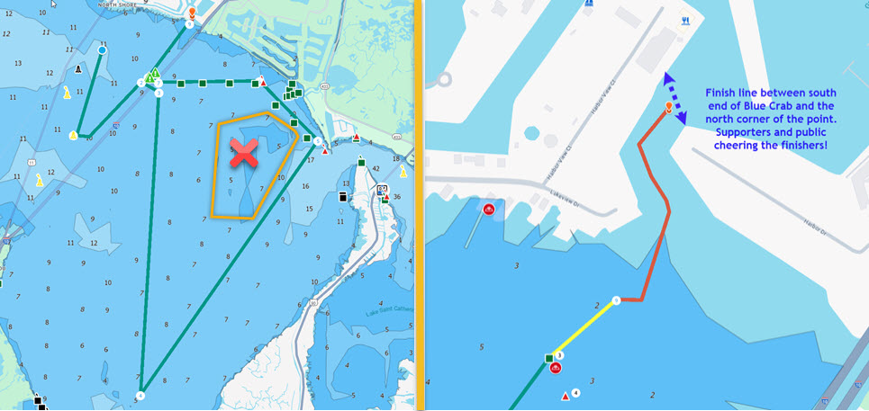

STARTING AND FINISHING LINES.

The starting line will be in an area downwind of a TYC mark. Either the “C” or the “Y” mark. The starting line will be between a staff displaying an orange flag on a committee boat and a nearby inflatable tetrahedron

Recall of boats on the course side at the start will be in accordance with rule 29 except that in addition to other provisions, the race committee will attempt to hail the yacht’s sail number on VHF Channel 68. Failure to hear hail is not grounds for redress.

The finish line area will be in the Oak Harbor entrance channel between the Blue Crab dock and the north point of the bulkhead across the channel. The finish line will be between a staff displaying an orange flag on a committee boat and the north point of the bulkhead across the channel.. TIME LIMIT. There is no time limit for the race. If no Committee Boat is on station competitors are instructed to record and report their own finishing time (GPS).

11 USE OF ENGINES. Engines may be used to transit the I-10 bridge channel and the
Oak Harbor channel for safety as deemed appropriate by the skipper. Boat speed shall not exceed the boat speed under sail alone prior to engaging the engine.

PROTESTS. Protests are not expected nor encouraged. Course distances are not subject to protest.

AWARDS. Prize awards are TBD and will depend upon the number of entries.

SAFETY. Each skipper has the sole responsibility for the safety of the crew and the seaworthiness of his or her yacht. Neither these sailing instructions nor the Racing Rules of Sailing shall in any way limit the skipper’s responsibility or confer any such responsibility on the sponsoring yacht club or the race committee. The entry form constitutes the skipper’s certificate of compliance with these conditions and any breach or violation of these requirements is subject to protest and is the skipper’s total responsibility.

ABANDONMENT OF RACE. Withdrawing yachts should notify the committee boat via channel 68 prior to leaving the course. In the event contact cannot be made, notification must be made by telephone to the RC, 985-290-4026 or to TYC, 985-649-5222 or to any Lake YC.

SPECIAL REGULATIONS FOR NON-SPINNAKER DIVISION. A single headsail, of the maximum size used for PHRF rating, or smaller, may be carried and tacked at the usual tack point with its luff attached not less than every 36 inches to the forestay by the means provided by the sailmaker.
Fore-staysails shall be allowed if tacked a minimum of 1/3 of the corrected “J” dimension behind the jib tack point and shall not exceed the rated overlap measurement for which the boat is rated.

Cutter rigs rated as such by the GYA PHRF Rating Committee may set staysails on the tack point provided by the vessel’s manufacturer.

SKIPPER’S MEETING. A Skipper’s Meeting will be held at Tammany Yacht Club on Friday, October 3rd, 2025, at 8:00 PM.

Revised 10/3/2025

